NEW TV SERIES FOR PEYO’S SMURFS
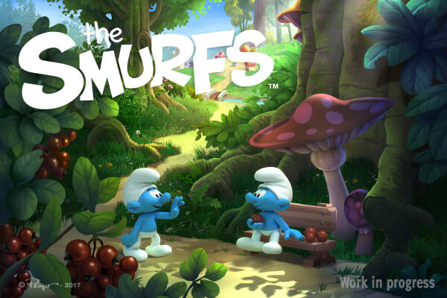
IMPS and Dupuis Audiovisuel have decided to join forces to produce a new Smurfs TV Series. The series is currently in pre-development. Episodes are planned to be 13 minutes long.
Véronique Culliford, President of IMPS, says:
Léon Perahia, CEO of Dupuis Audiovisuel, says:
Peyo, born Pierre Culliford, created the Smurfs in 1958.
IMPS, run by Véronique Culliford, is the official licensor of the little blue-skinned characters. Since 1984 IMPS has worked in close collaboration with its agents worldwide to develop successful licensed merchandising programs, retail- and co-branded promotions, publishing activities, broadcasting deals, theme parks, live shows, video games, online games, Smurf music… that have secured the everlasting success of the Smurfs.
Dupuis Audiovisuel, created in 1990, is a trusted name in screen adaptations of famous European comics like Spirou, Little Spirou, Papyrus, Jojo, Cedric, Kid Paddle, Little Furry, Marsupilami, to name a few. Dupuis Audiovisuel is a subsidiary of Media-Participations, a major European entertainment group, with titles such as The Garfield Show, Tintin, Asterix, Lucky Luke, and The Red Turtle. The group has 2 animation studios: Ellipsanime in France and Dreamwall in Belgium.

